Project | Opencart
Tested by | Vishwa
Test Execution Date | dd-Mmm-yy
Test Cycle | 1
Test Environment | localhost
Version, Release, Build Number | 1, 1, 1
Test Scenario Number | TS0001
Test Scenario | Register Functionality
Test Case ID | TC_RF_0011
Test Case Description | Validate Registering an account by providing invalid Telephone number
Test Steps | 1. Click on 'My Account' drop-down menu  2. Click on 'Register' option  3. Enter new account details into all fields(First Name, Last Name, Email, Password, Password Confirm, Newsletter, privacy policy)  4. Key in the invalid Telephone number. <Refer to test data>  4. Click on 'Continue' button (ER-1)
Test Data | 98111111A$
Expected Result | 1.Proper field level warning message should be displayed and account should not be created.
Actual Result | 1. Warning message is not getting displayed and an Account is getting created with the given invalid phone number
Test Result | Fail
Bug/Defect ID | OCD0001
Steps to Reproduce | As given in Test Steps

- Click on 'My Account' drop-down menu
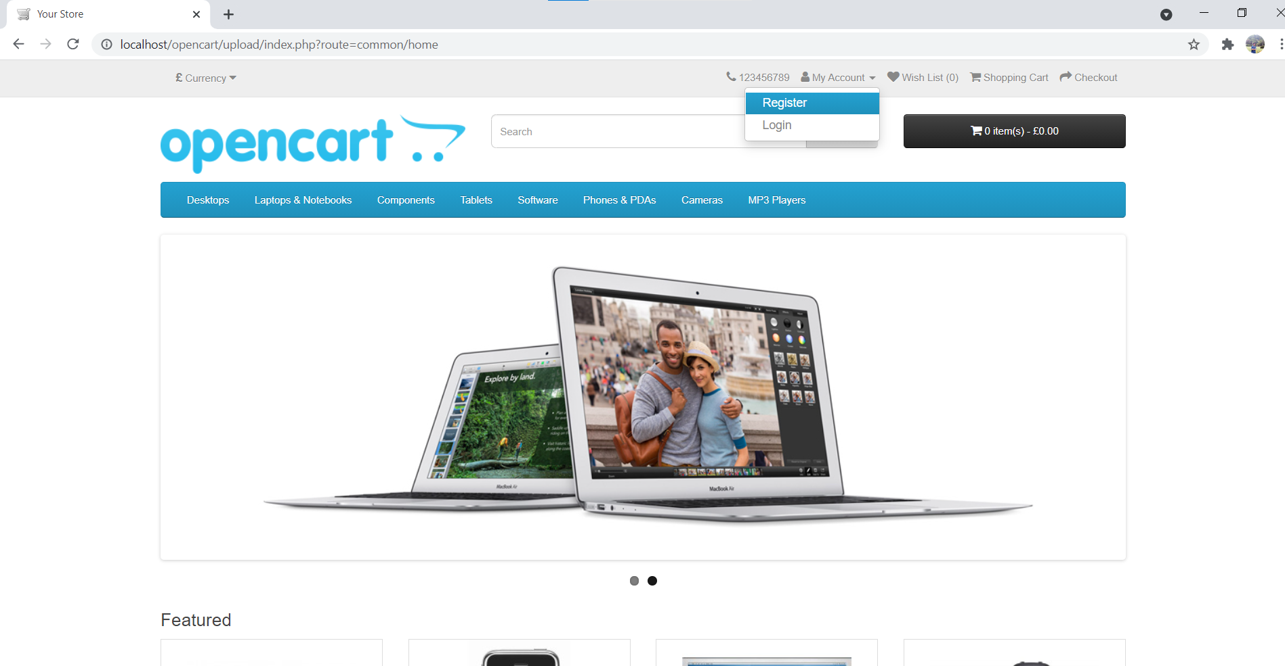

- Click on 'Register' option
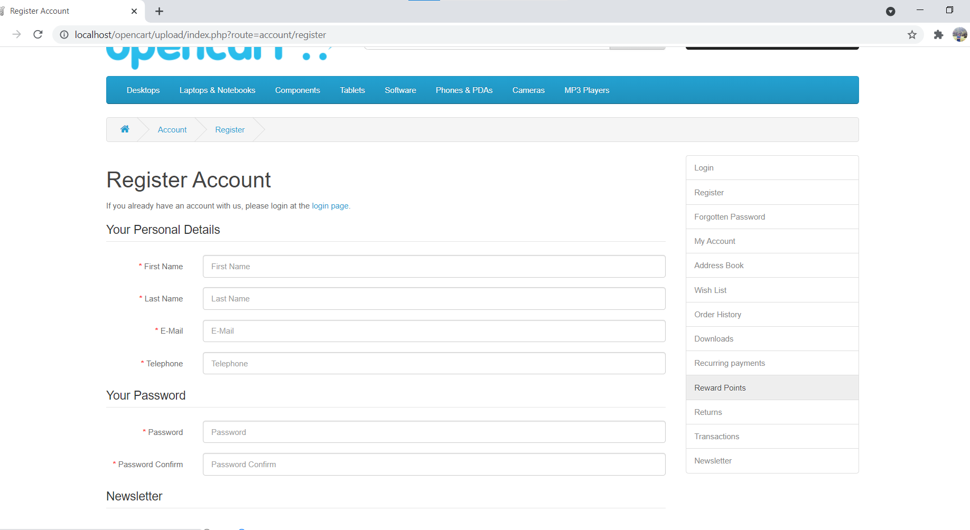

- Enter new account details into all fields(First Name, Last Name, Email, Password, Password Confirm, Newsletter, privacy policy)
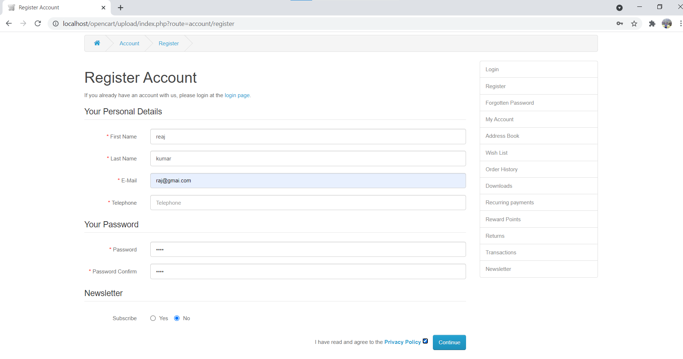

- Key in the invalid Telephone number. (98111111A$)

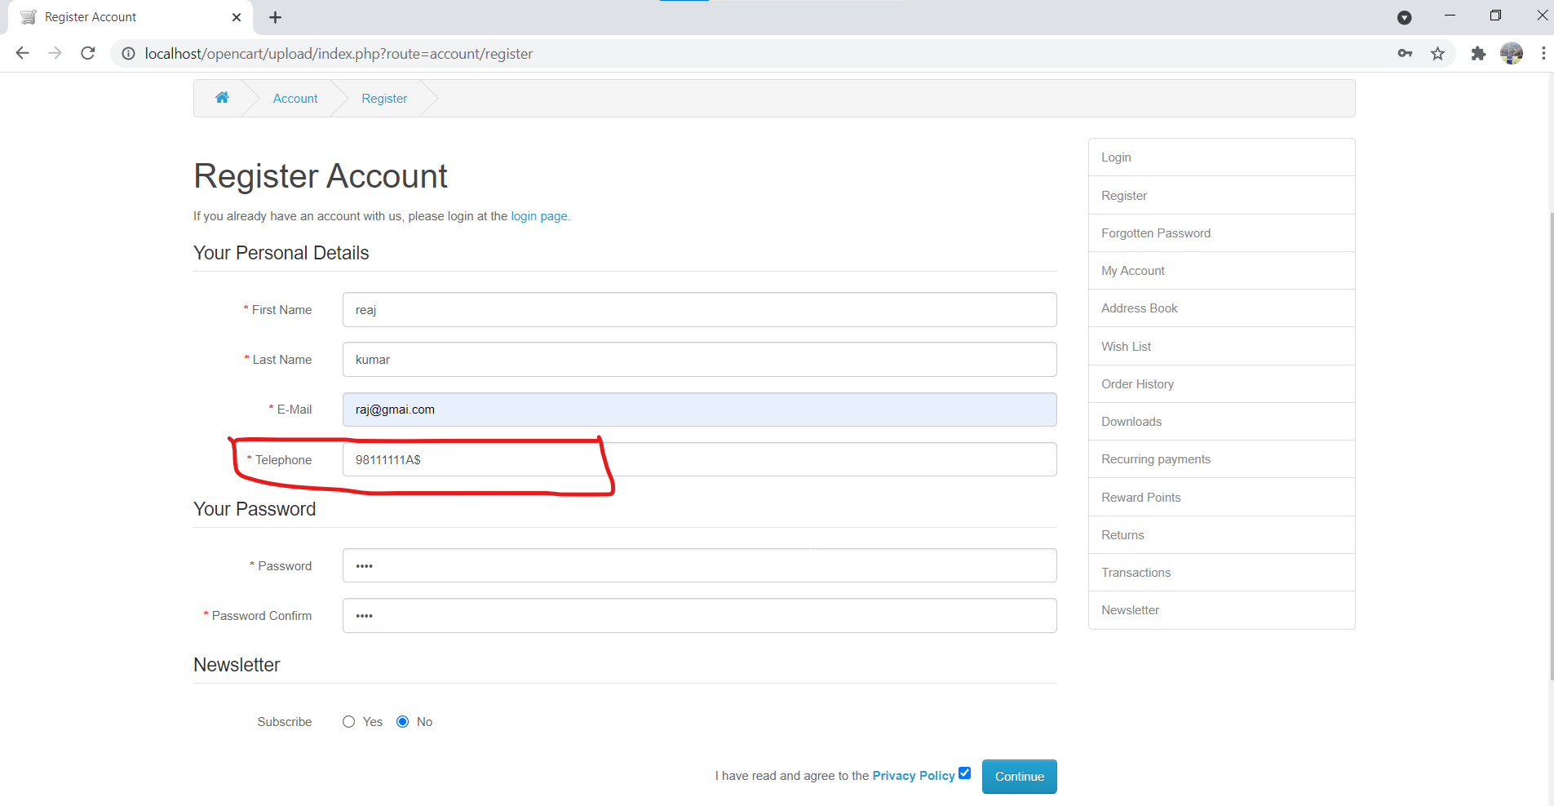

- Click on 'Continue' button (ER-1)

